Note:Static routes unlike Local and Connected routes enables routers to send packets to remote destinations,that aren’t directly connected to router itself.
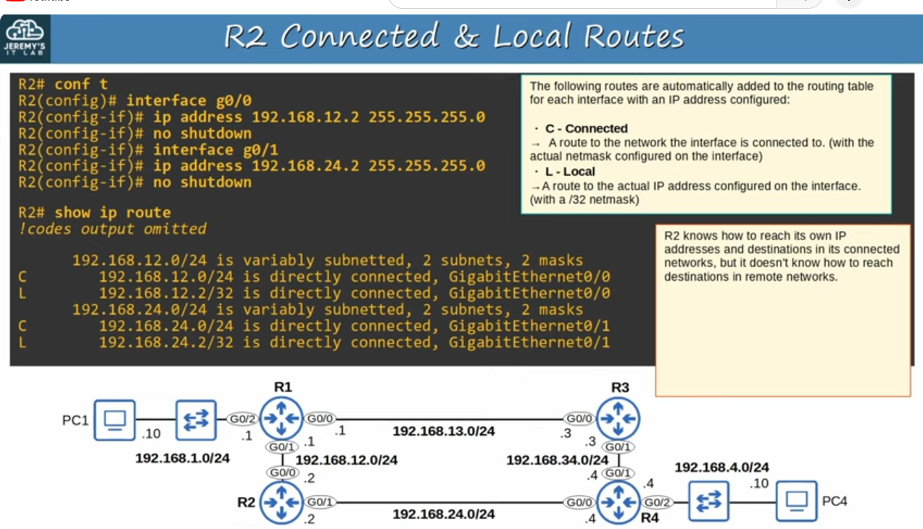
Review of Connected and Local routes
Note: (in addition to second box,with red frame) remote network refers to network which is not directly connected to R2.
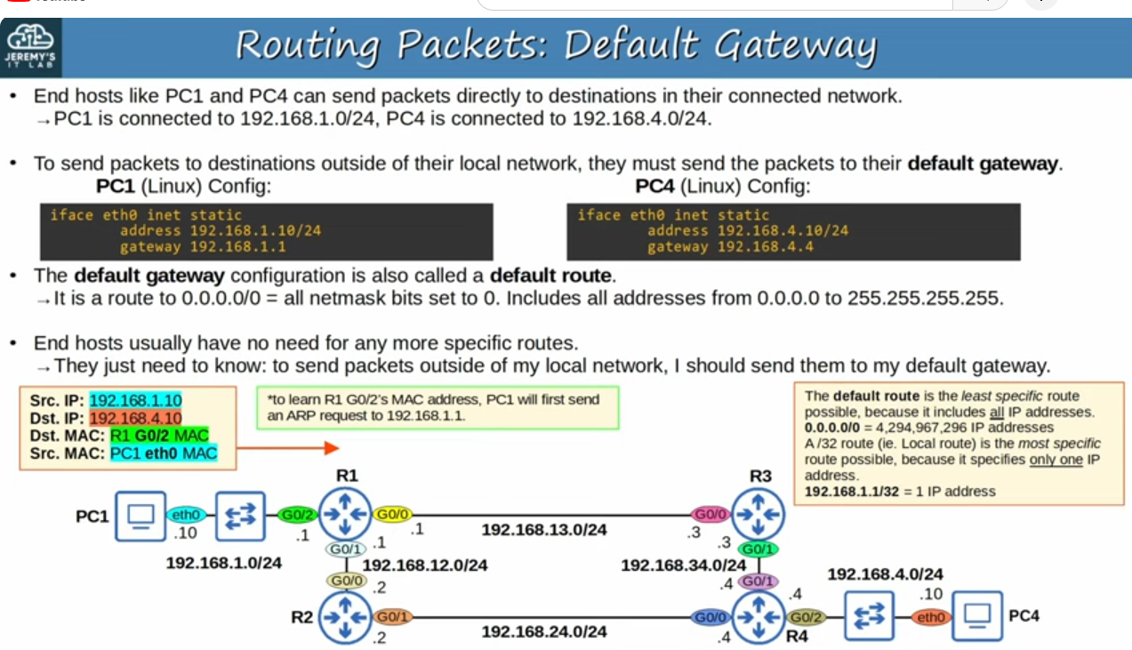
Note: PC1 and PC4 are linux hosts,and their default interface name is eth0.
Note: (in addition to second point) gateway is an old term for router,so default gateway means default router
Note: In linux interface, configurations are stored in a text file that we can edit.On PC1 there is the line ‘address 192.168.1.10/24’,which configures IP address as 192.168.1.10/24(On terminal example).
Note: Default gateway configuration on PC1 for example is on the line ‘gateway 192.168.1.1’.So to send packets to destinations outside of it’s local network,PC1 will send packets to R1.
Note: The packet above the PC1, PC1 wants to send it to PC4. So Dst IP is IP of PC4,however it has to first forward the packet to it’s default gateway(R1), so it will encapsulate the packet in the frame and the Dst. MAC will be R1’s G0/2 MAC.

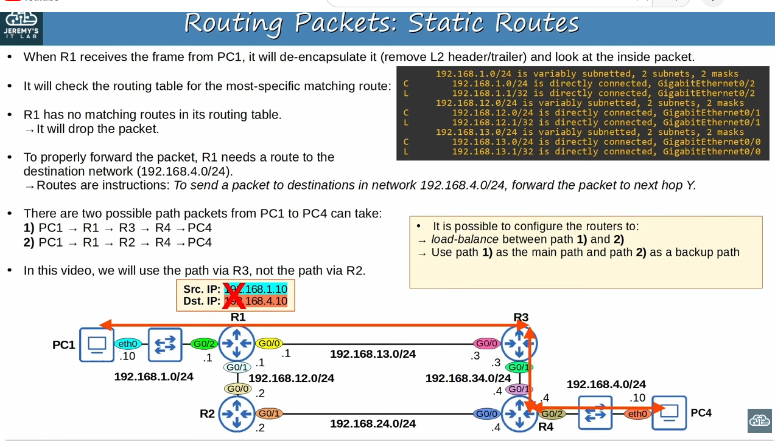
Note: Routes are instructions.(from 4 th point below text).Next-hop Y is reffered to router.
Note: If there are multiple paths to the destination,we can choose which one the routers use.(continuation in yellow box ‘It is possible to configure the …’).Instead of choosing one path they can load-balance between path1 and path2.That means some packets will take path 1 and some will take path2.Or they could for example ,use path1 as the main path,and path2 as a backup path(from yellow box)

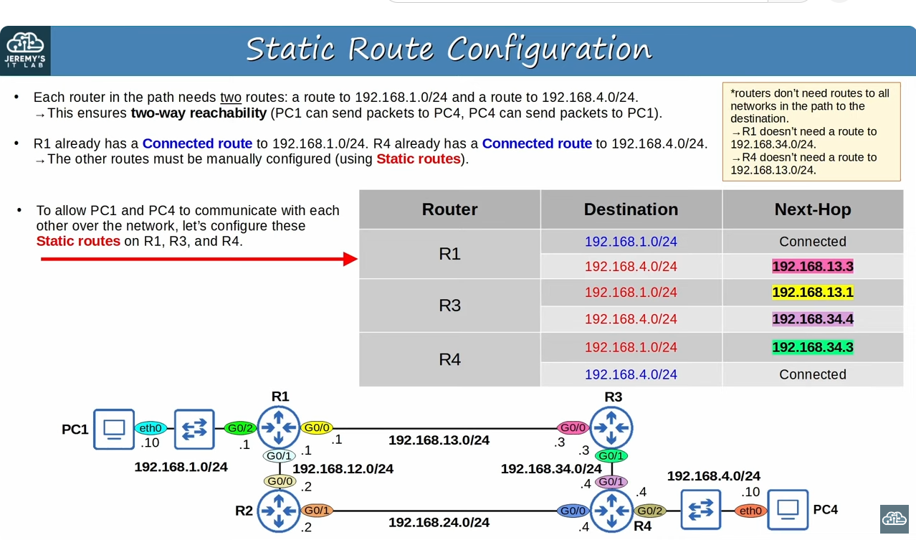
Note: To ensure PC1 and PC4 can communicate with each other it’s not that just R1 needs another route.Each router needs two routes.(continuation in first point)
Note:(in continuation to second point) If for example ,all routers had routes to 192.168.4.0/24,but not 192.168.1.0/24,PC1 would be able to send packets to PC4,but PC4’s replies wouldn’t be able to reach PC1.R4 would drop the reply because it would have no route that matches destination 192.168.1.10.So we want two-way reachability.
Note: (in continuation to yellow box ) routers don’t need routes to all networks in the path to the destination.It just needs to know,to send a packet to 192.168.4.0/24 ,it should send the packet to R3.R3 will take the care of the packets after that.
Note: The chart in gray shows routes that R1,R3,R4 need to allow PC1 and PC4 communicate.In blue are R1’s connected routes.Then,in red are the static routes that we must configure.
Note:Because we are using path(from PC1 to PC4) via R3,the Next-hop for R1 192.168.4.0/24 address will be 192.168.13.3/24(R3’s G0/0 interface).R1 has a connected route to 192.168.13.0/24,so it knows how to reach 13.3.It can then use that IP address as a next-hop to send packets toward the 4.0/24 network.
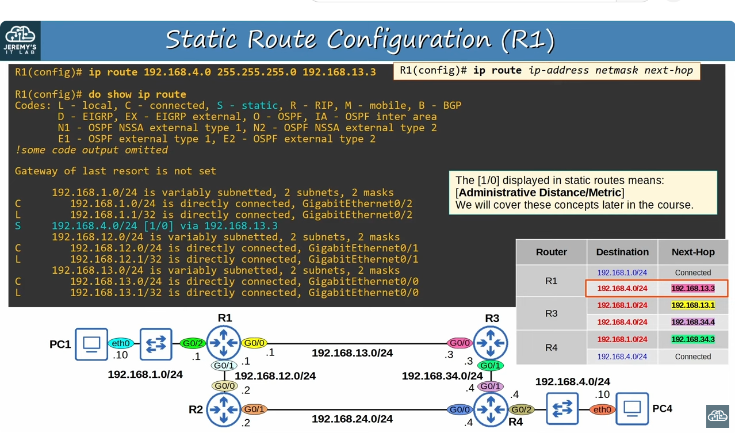
Configuring static routes on R1(Configuring R1’s route to 192.168.1.0/24 network) with command ‘ip route <destination network ip-address> <netmask> <next-hop ip-address>’ from global config mode
Note: Static route code(top) and Static route in the routing table are highlighted wih blue(S).
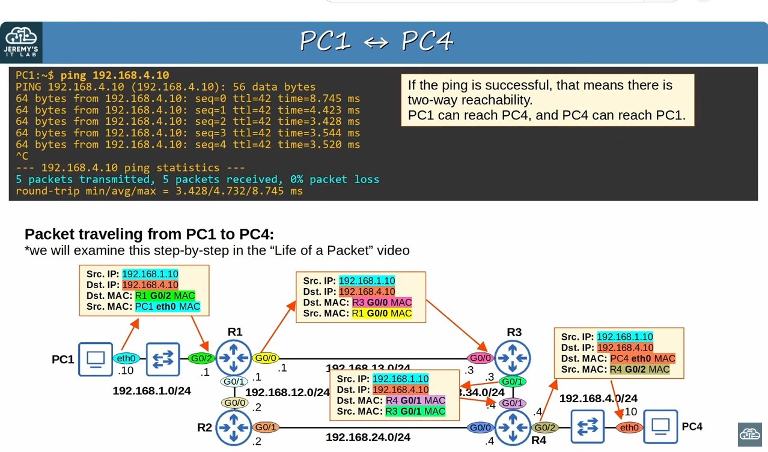
Briefly ‘Life of a packet’,about how packet from PC1 is encapsulated,de-encapsulated and re-encapsulated in the network as it travels through the network
1) When PC1 sends a message to PC4,the layer 3 destination is PC4’s IP address(192.168.4.10),however at layer 2 the destination is PC1’s default gatewy,which is R1’s G0/2 interface.
2) Now it’s R1’s packet and it’s R1’s job to forward it to the next-hop,R3.To do so it encapsulates the packet in a new Ethernet frame.This time the destination of the frame is the next-hop’s MAC address,so the MAC of R3’s G0/0 interface.
3) Now R3 has the packet and must forward it to the next-hop.To do that,it once again encapsulates the packet in a new Ethernet frame,and the destination of that frame is the MAC of R4’s G0/1
4) Now R4 has the packet,and sinc its directly connected to the destination network,it can forward the packet to PC4.It does that by encapsulating the packet in a frame with PC4’s MAC as the destination
Note: Destination and Source IP’s of the packet do not change throughout the journey,but each time the packet is de-encapsulated and re-encapsulated,the source and destination MAC addresses are different.
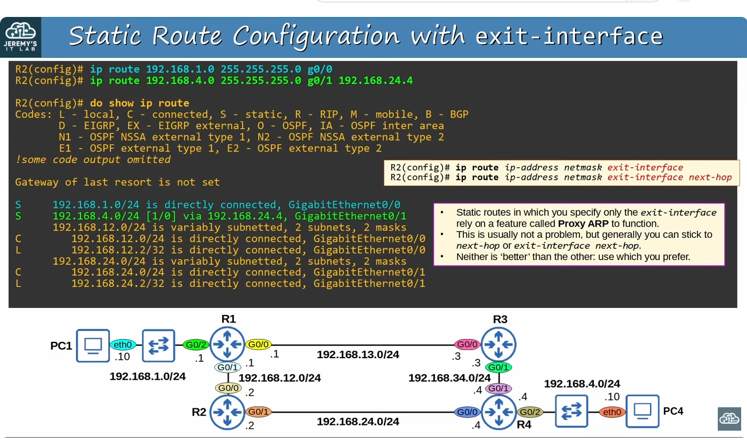
‘exit-interface’ option
Note: When configuring static routes,instead of configuring next-hop(it’s IP address),we can configure exit-interface instead,that mean we specify which interface this router should send the packet out of,rather than telling it the actual IP-address of next-hop.For example if R2 wants to send packets to the 192.168.1.0/24 network,it should send the packets to R1.R2 should send packet to G0/0 to reach R1,because that interface is connected to R1.
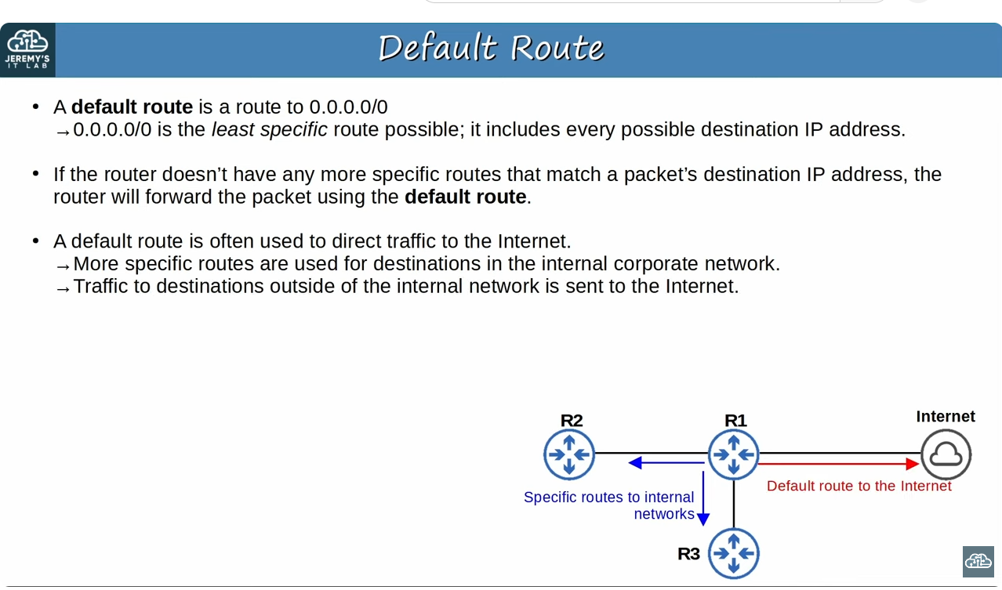
Note: We can configure both next-hop and exit-interface.When we specify only exit-interface of the static route,it says the destination network is directly connected(highlighted in blue),but that network is not directly connected to R2,but that’s how it displays in rouing table when we configure only the exit-interface.(continuation in box with pink frame),this is not a problem,but we can generally stick only next-hop or next-hop and exit-interface both.So finally we can configure only exit-interface,only next-hop,or both of them.

Default router
Note: in the first text below third point More specific routes refer to R2 and R3,which are used for destinations in the internal corporate networks(such as destinations connected to R2 and R3). However traffic to destinations outside of the internal network is sent to the internet,using the default route.This isn’t the only way to use a default route,but it’s a very common use case.

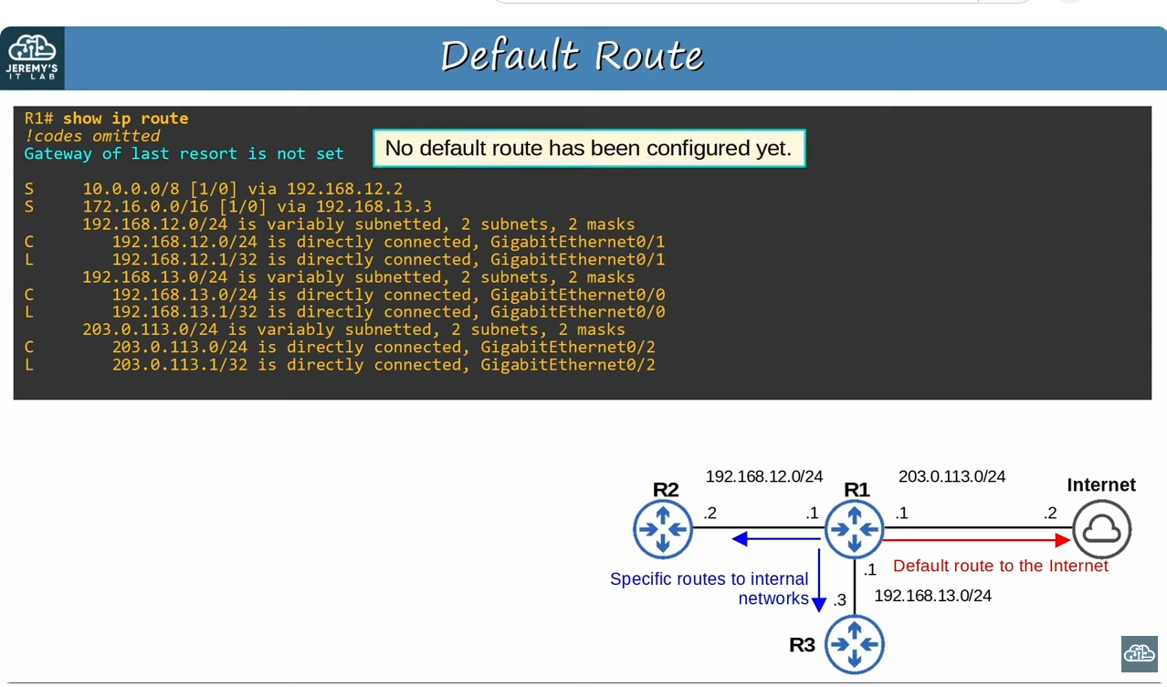
R1’s routing table.(Static routes are configured already)
Network topology of some company

Note: the meaning of line highlighted in blue is next to it in the yellow box.’Gateway of last resort’ is another name for ‘default gateway’.
Note: In R1’s routing table there is a route to 10.0.0.0/8 with R2 as the next-hop and a route to 172.16.0.0/16 with R3 as the next hop,and these are networks used by company internally.
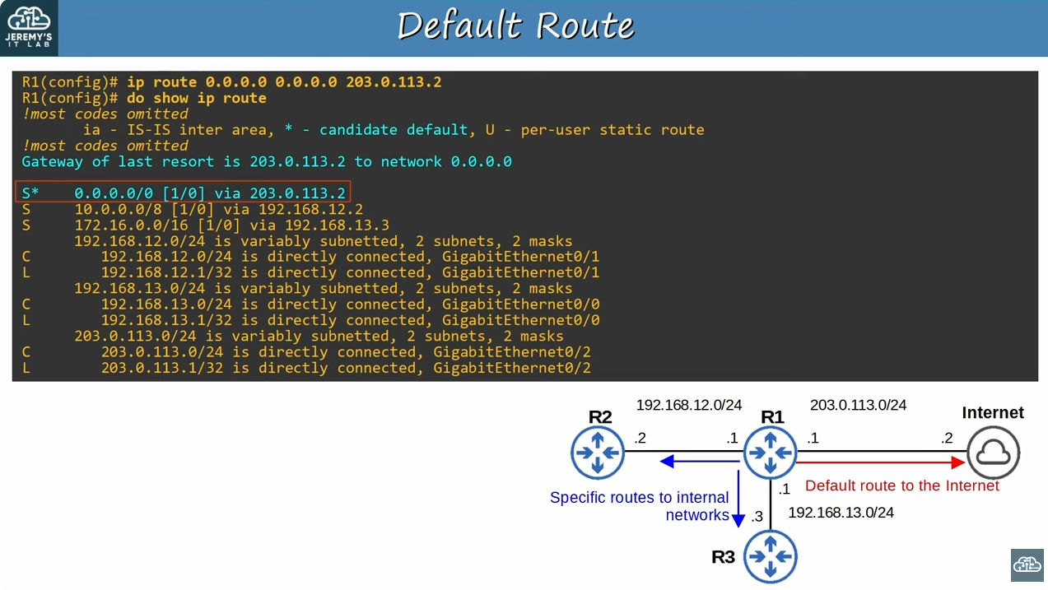
Configuring a default route.
Note: ‘ip route’ command’s network and netmask should be 0.0.0.0.When configuring a default route.
Note: After configuring with ‘ip route’,R1 has default route.That route is the first route in routing table(highlighted in blue,S*)
Note: Next to the S code indicating that it’s a static route,there is an asterisk.In codes legend it says that the asterisk is the candidate default.It means this route is a candidate to become the router’s default route. It’s possible to have multiple candidates.In this case there’s only this one,and ‘Gateway of last resort is 203.0.113.2 to network 0.0.0.0’ states that the route we configured was indeed selected.

From lab 11(par1)
Point-to-point interface
Point to point interface connects only to one other device.This is different than,for example,many routers connected to a single switch,which we would call a shared segment.
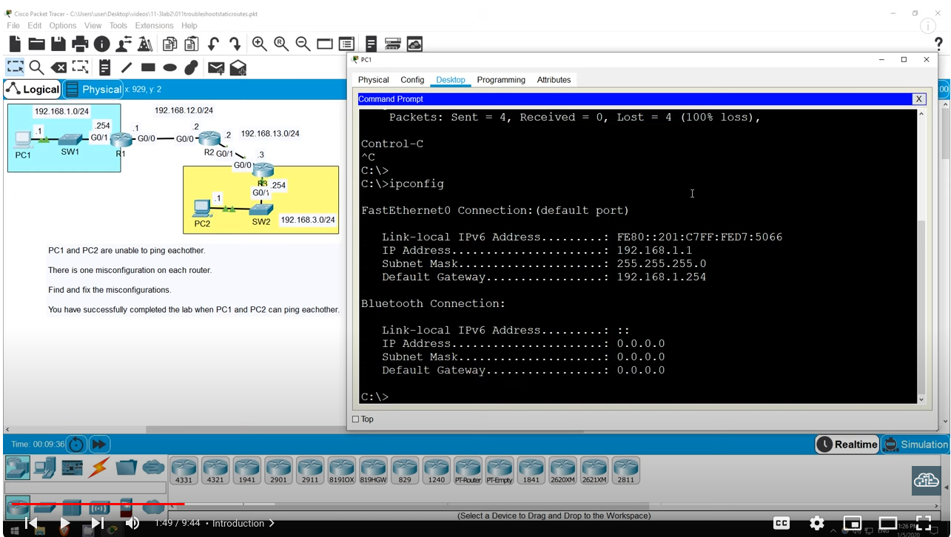
‘ipconfig’ command
To check the configuration on windows pc we use ipconfig command.
Note: Here it shows configurations for example for FastEthernet0.
Note: ‘ipconfig /all‘ gives more information(for example Physical address).

Filtering the output of running-config with pipe and ‘include command’
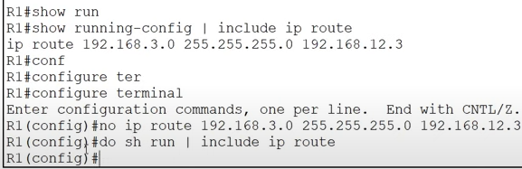

Deleting the configuration statement with ‘no’ command and checking if it is deleted with ‘do sh run | include ip route’

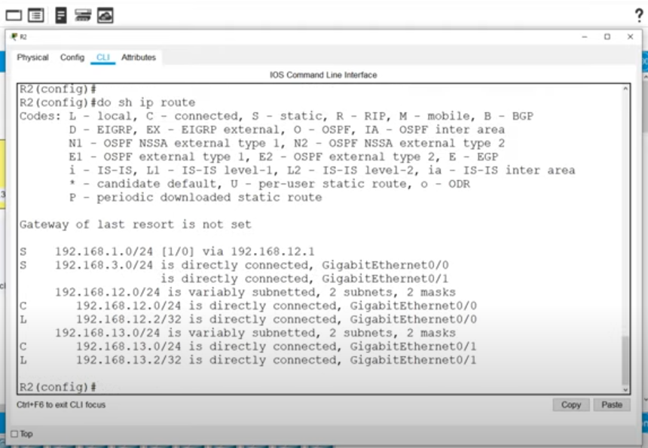
Note: If we enter the correct route without removing the incorrect route the network and we enter,it does not override the incorrect one,both routes are kept in the routing table.Because both are in the routing table,this means the router will load-balance over the two routes sending some packets out of G0/0 and some packets out of G0/1.

